**FriendlyElec NanoPC-T4 Rockchip RK3399 Single Board Computer**

**Product Description**

The NanoPC-T4is a perfect platform for AI and deep learning applications. It can be widely used in advertisement machines, game machines, video conference applications, surveillance systems, clusters, VR/AR applications, machine vision applications and etc. The NanoPC-T4 supports GPU and VPU acceleration and works with Android 8.1 and Lubuntu Desktop.

**Company Name:** youyeetoo

**Price:** $175.99

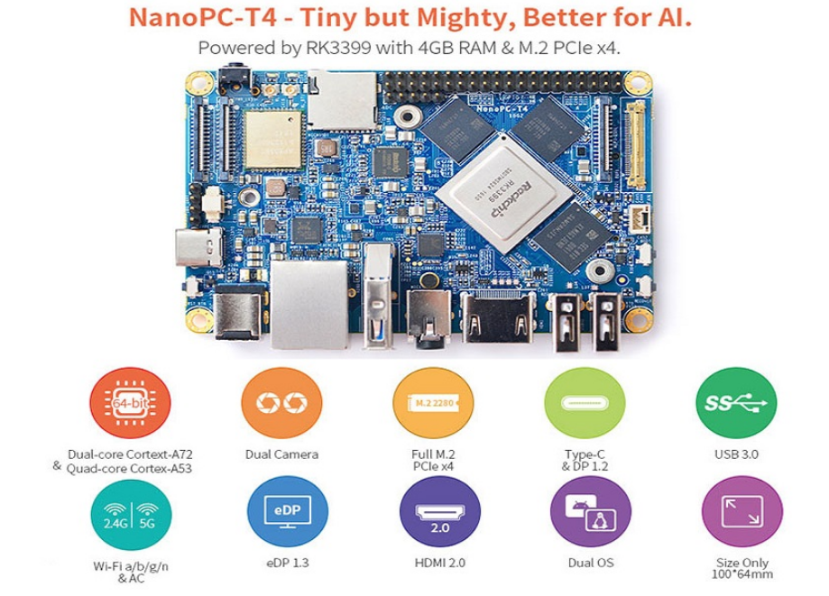

**Layout & Interface**

